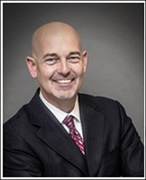 |  | Kevin Fowler
 |  | Kevin Fowler was elected to the Rockwall City Council in 2015. Kevin has lived in Rockwall since 2000 where he has been active in the Rockwall community serving in leadership roles on a number of boards and city appointed commissions including the Rockwall Economic Development Corporation, Building Better Roads Bond Committee, Rockwall Business and Education Committee, the Rockwall Area Chamber of Commerce, the Rockwall Rotary Club, Lake Pointe Hospital, the YMCA, Boy Scouts of America, Rockwall Youth Fair and CASA. He has been in the banking industry nearly 30 years and is currently City President at MidSouth Bank in Rockwall.
 | His education includes a B.S. in Finance from Louisiana State University in Baton Rouge, LA and is a graduate of Southern Methodist University’s Southwestern Graduate School of Banking. Kevin is a member of First Baptist Church of Rockwall. He is married to Amanda and has 4 children, Jake, Davis, Grace and Dawson.

